Deep Learning with Principal Component Wavelet Networks

CS39440 Major Project Report

Author: Samuel Spurling ([sas90@aber.ac.uk](mailto:sas90@aber.ac.uk))

Supervisor: Dr Bernie Tiddeman. My Supervisor (bpt@aber.ac.uk)

29th March 2022

Version 1.0 (Release)

This report is submitted as partial fulfilment of a BSc degree in  
Computer Science and Artificial Intelligence (With Integrated Year in Industry) (GG47)

Department of Computer Science

Aberystwyth University

Aberystwyth

Ceredigion

SY23 3DB

Wales, UK

Declaration of originality

I confirm that:

* This submission is my own work, except where clearly indicated.
* I understand that there are severe penalties for Unacceptable Academic Practice, which can lead to loss of marks or even the withholding of a degree.
* I have read the regulations on Unacceptable Academic Practice from the University’s Academic Registry (AR) and the relevant sections of the current Student Handbook of the Department of Computer Science.
* In submitting this work, I understand and agree to abide by the University’s regulations governing these issues.

Name ……Samuel Spurling……………

Date …………30/04/2022……………

Consent to share this work

By including my name below, I hereby agree to this project's report and technical work being made available to other students and academic staff of the Aberystwyth Computer Science Department.

Name ………Samuel Spurling………

Date ………………30/04/2022………

Acknowledgements

I am grateful to my project supervisor for his excellent guidance and advice, my flatmate for her constant support and encouragement, and my personal tutor for being a benevolent and reliable presence in my time at university.

Abstract

In this report we propose a novel application for Principal Component Wavelet Networks (PCWN) [1]. The PCWN decomposes an image using handcrafted invertible 2D wavelet filters-banks and 1x1 filters learnt through principal component analysis to control the size of decompositions. The reconstruction is accomplished using the inverted filter bank and an approximately inverted PCA. Previously the approach has shown competitive results for linear inverse problems in computer vision such as compressive sensing, super-resolution, and in-painting. The proposed novel application is image segmentation. This is a task where there are objects in an image and through segmentation the image is split into distinct components, or segments, where each segment represents an object in the image.

We use 2 variants of the PCWN, a fully convolutional and a fully connected approach. In experiments, there will be a comparison of the PCWN approach to the U-net model, a standard architecture for image segmentation, to benchmark the PCWN models performance. The results of the experiments demonstrate that PCWN has great potential when applied to the task of image segmentation. Possible future work looks at using PCWN as regularisation in the U-net architecture and replacing PCA with a different kind of invertible dimensionality reduction such as Kernel PCA or UMAP.

Figure 1: Image segmentation: Difference between semantic and instance [14] 11

[Figure 2: Illustration of tanh and atanh 12](https://d.docs.live.net/455c1cc37aadd471/Desktop/major_project/MajorProject/Writeup/Writeup/MajorProject.docx#_Toc102212338)

[Figure 3: Wavelet decomposition of an image of a bird 13](https://d.docs.live.net/455c1cc37aadd471/Desktop/major_project/MajorProject/Writeup/Writeup/MajorProject.docx#_Toc102212339)

Figure 4: PCA training process [1] 14

[Figure 5: U-net architecture [3] 15](https://d.docs.live.net/455c1cc37aadd471/Desktop/major_project/MajorProject/Writeup/Writeup/MajorProject.docx#_Toc102212341)

[Figure 6: Example of high-resolution features being used to localize low-resolution features [3] 16](https://d.docs.live.net/455c1cc37aadd471/Desktop/major_project/MajorProject/Writeup/Writeup/MajorProject.docx#_Toc102212342)

[Figure 7: Atrous convolution: Atrous rate = 1 16](https://d.docs.live.net/455c1cc37aadd471/Desktop/major_project/MajorProject/Writeup/Writeup/MajorProject.docx#_Toc102212343)

[Figure 8: Atrous convolution: Atrous rate = 2 16](https://d.docs.live.net/455c1cc37aadd471/Desktop/major_project/MajorProject/Writeup/Writeup/MajorProject.docx#_Toc102212344)

Figure 9: screenshot of the Kanban board used for tracking tasks, using click-up https://app.clickup.com/ 17

Figure 11: Visualisation of IOU [27] 20

Figure 12: Fully connected PCWN architecture 23

[Figure 13: Fully convolutional PCWN architecture 24](https://d.docs.live.net/455c1cc37aadd471/Desktop/major_project/MajorProject/Writeup/Writeup/MajorProject.docx#_Toc102212348)

[Figure 14: Original image of bird 25](https://d.docs.live.net/455c1cc37aadd471/Desktop/major_project/MajorProject/Writeup/Writeup/MajorProject.docx#_Toc102212349)

[Figure 15: Image of bird with mask applied 25](https://d.docs.live.net/455c1cc37aadd471/Desktop/major_project/MajorProject/Writeup/Writeup/MajorProject.docx#_Toc102212350)

[Figure 16: Inverted segmentation mask 25](https://d.docs.live.net/455c1cc37aadd471/Desktop/major_project/MajorProject/Writeup/Writeup/MajorProject.docx#_Toc102212351)

[Figure 17: Original segmentation mask 25](https://d.docs.live.net/455c1cc37aadd471/Desktop/major_project/MajorProject/Writeup/Writeup/MajorProject.docx#_Toc102212352)

Figure 18: A graph of training data vs mean dice score 27

Figure 19: A graph of keep percent vs mean dice score 28

Figure 20: A graph of layer count vs mean dice score 28

Figure 21: A graph of image resolution vs mean dice score 29

Figure 22: Example segmentation from the convolutional PCWN, dice score = 0.820 ± 0.160 29

Figure 23: A graph of training data vs mean dice score 29

Figure 24: A graph of keep percent size vs mean dice score 30

Figure 25: A graph of layer count vs mean dice score 30

Figure 26: A graph of resolution vs mean dice score 31

Table 1: Table of features 18

Table 2: An experiment on the effect of training size on convolutional PCWN 27

Table 3: An experiment on the effect of keep percent on convolutional PCWN 27

Table 4: An experiment on the effect of layer count on convolutional PCWN 28

Table 5: An experiment on the effect of image resolution on convolutional PCWN 28

Table 6: An experiment to show the effect of training data size on connected PCWN 29

Table 7: An experiment to show the effect of keep percent on connected PCWN 30

Table 8: An experiment to show the effect of layer count on connected PCWN 30

Table 9: An experiment to show the effect of image resolution on connected PCWN 30

Contents

1 Background, Analysis & Process 9

1.1 Background 9

1.2 Analysis 9

1.2.1 Fundamentals 9

1.2.2 PCWN 12

1.2.3 Deep Learning Architectures for Segmentation 15

1.2.4 Research Questions 16

1.3 Process 17

1.3.1 Overview 17

1.3.2 Iteration 0 - Setup 19

1.3.3 Iteration 1 19

1.3.4 Iteration 2 19

1.3.5 Iteration 3 19

1.3.6 Iteration 4 19

2 Experiment Methods 19

2.1 Hypotheses 19

2.2 Hardware 19

2.3 Datasets 20

2.4 Metrics and Measurements 20

2.4.1 Dice Coefficient and Intersection Over Union (IOU) 20

2.4.2 Other Metrics 21

2.5 Measuring Performance 21

3 Software Design, Implementation and Testing 21

3.1 Design 21

3.1.1 Overall Architecture 21

3.1.2 PCWN 21

3.1.3 Deep Learning Methods 25

3.2 Implementation 26

3.2.1 Language 26

3.2.2 Development Software 26

4 Results and Conclusions 26

4.1 Testing of system 26

4.1.1 Overall Approach to Testing 26

4.1.2 Stress Testing 26

4.2 Issues with Experiments 26

4.2.1 Memory Errors 26

4.3 Experimental Results 27

4.4 Determining best parameters for PCWN segmentation method 27

4.4.1 Convolutional Network Approach 27

4.4.2 Connected Network Approach 29

4.5 Experimental Results: PCWN vs Deep Learning 31

5 Critical Evaluation 31

5.1 Background and Research 31

5.2 Design 32

5.3 Implementation 32

5.4 Testing 32

5.5 Methodology 32

5.6 Reflection 33

6 Bibliography 33

7 Appendices 35

A. Third-Party Code and Libraries 36

B. Code Samples 37

# Background, Analysis & Process

## Background

The motivation for this project stems from an interest in computer vision, dimensionality reduction techniques, and a curiously for wavelets. Image segmentation is an active field of research, with applications in medical imaging, satellite imagery and image-based search.

The project extends the Principal Component Wavelet Network (PCWN) method [1] to the task of image segmentation, so naturally PCWN was a key part of the background research. The motivation for this was to understand the novel approach to linear inverse problems and apply my findings to an image segmentation approach. Convolutional scattering wavelet networks [2] is another method which shares similarities to PCWN, especially on methods for mitigating the issue of large channels after multiple applications of wavelet filter banks. To understand the segmentation task, there was research of U-net [3], DeepLabV3 [4] and a comparison of segmentation methods [5].

## Analysis

### Fundamentals

#### Principal Component Analysis

Principal Component Analysis (PCA) is a method of dimensionality reduction that calculates “principal components” and then orients the data using the principal components as basis vectors. The advantage of using PCA is that high dimensional data can be expressed in lower dimensions whilst retaining almost all the variance between data points. Consequently, the curse of dimensionality [6] can be avoided when using PCA in machine learning, where higher dimensions cause an increase in sparsity, causing data objects to appear dissimilar which impacts the algorithms’ ability to learn.

Given an input matrix of data A, this is how to calculate the principal components. First the covariance matrix and the mean of the data is calculated. The mean is subtracted from the data to standardise the data.

$$cov =\sum{x_{i}^{t}x_{i}}, \overline{x}= \frac{\sum{x_{i}}}{n}$$

$$A = A - \overline{x}$$

The principal components are found by calculating the eigenvectors and eigenvalues of the covariance matrix, and then the eigenvectors are ordered using the eigenvalues. A n-dimensional dataset has n principal components. The sum of the eigenvalues of n principal components is the total variance, therefore we can calculate explained variance by dividing the eigenvalue of a component by the sum of the eigenvalues. The total explained variance is found by summing the explained variance for each component selected. The following is an example of eigenvectors $v$ and eigenvalues $λ$.

$$v_{1} = [0.5, 0.1], λ_{1}=1.5$$

$$v_{2} = [0.2,0.6], λ_{2}=0.8$$

The eigenvectors of the covariance matrix are the direction of the axes which have the highest variance, and the eigenvalues are the amount of variance in the respective components. The feature vector is formed using the eigenvectors like so.

$$B=\left[\begin{matrix}0.5 & 0.1 \\ 0.2 & 0.6\end{matrix}\right]$$

We are applying PCA to the feature maps produced by the filter banks. Finding the dot product of the feature maps (A) and the transpose of the feature vector (B) produces a dimensionally reduced feature map (C) that retains most of the information of the higher dimension feature map.

$$C=A∙B^{T}$$

#### Convolutional Neural Networks

An artificial neural network (ANN) is a directed and weighted graph where neurons are nodes and neuron connections (weights) are edges. ANNs are composed of layers, where every layer is a collection of neurons. The most common architecture is feed-forward. In this architecture every layer is connected to another layer, except the output layer, which only has a incoming connections. ANNs typically consist of three types of layers, input, output and hidden. The hidden layers of an ANN allow them to function as universal function approximators. That is to say, with the correct architecture and parameters an ANN can model any function to a small degree of error. Finding the correct architecture and parameters is a complex task with no general solution, and there are no guarantees of optimality. Typically, ANN’s are trained using vast amounts of data and an error update algorithm that tweaks the parameters of the network towards a more optimal solution. Normally this algorithm is backpropagation [7].

There are many architectures other than feed-forward networks, such as Recurrent Neural Networks (RNNs), transformers, Self-Organising Maps (SOMs) and autoencoders. The architecture used for this project is Convolutional neural networks (CNNs).

CNNs are a commonly used architecture in computer vision. Popularised by Kunihiko Fukushima [8] and Yann LeCun [9] between 1980-1990, CNNs have a number of desirable qualities for computer vision tasks. CNN’s work using convolutional filters, which are 2D matrices, or kernels, that slide over the image and “convolve” with patches on the image. A convolution measures the strength of a signal at a particular patch on the image. Multiple kernels can be used in parallel to generate deep feature maps, and the kernels can have any size. The size of the steps taken when sliding the kernel over an image is called the stride. A stride of 2 means that a pixel is skipped with every step. Below is the equation used to calculate the value of a 1D feature map, y, at location [m, n]. The variable x is the image we are convoluting, and h is the feature map. The $*$ operator is used as shorthand for a convolution operation.

$$y\left[m\right]=\sum_{i}{x[i]∙h[m-i]}=x\left[m\right]*h[m]$$

The kernel values are learnt through error update, the same as any other neural network. Typically, they are initialised randomly, although there are several handcrafted filters which can be used to initialise the kernels. For example, there are filters for edge detection and gaussian blurring.

The main advantage of using convolutions instead of a fully connected solution is the massive reduction in connections in the network relative to a standard densely connected network. In a feed-forward network, the number of connections scales exponentially with the resolution of the image. Every one of these connections requires an error update when training, which introduces a massive computational overhead. The network will also struggle to generalise, resulting in overfitting. A CNN uses convolutions and pooling to minimise the connections between layers and lead to more efficient computation. Pooling is an operation which further reduces the size of feature maps. Max-pooling, for example, takes the largest value in a small window, discarding the other values.

#### Wavelets

Appropriate image representation is key to the success of an algorithm. There exist several different representations. The most familiar representation is the spatial domain. The spatial domain is how we view digital images, with resolution, colour channels and pixel intensity values. Other representations include the Fourier domain and wavelets.

Wavelets transforms are similar to Fourier transforms, except that whereas Fourier can only capture frequency information, wavelets can capture frequency and location information. Both Fourier and wavelet transforms measure signal strength. For Fourier transforms, this means which frequencies have the largest amplitudes in the frequency domain of an image. For wavelet transforms, signal strength is a measure of how much of a wavelet is in a signal. This may sound like a convolution, and that’s exactly what a wavelet transform is. This is shown by the discrete wavelet transform formula below, where W is a bank of wavelet filters, t is the location in the image, x is the image and y are the output feature map.

$$y\left[t\right]=\sum_{φ∈W}{x\left(t\right)*φ_{m,n}(t)}$$

Wavelets can be classified as discrete or continuous. Wavelets have been in use since the early 20th century, originating with Harr wavelets [10] which have enjoyed a wide range of applications, notably in Viola-Jones facial detection [11]. Harr wavelets are discrete wavelet transforms. There are many applications of wavelets, for example scattering wavelets are used in convolutional scattering wavelet networks [2]. This method in the paper used sets of different scale Morlet wavelets, an approach which has desirable properties such as deformation, rotation, and scale invariance. Morlet wavelets do not have a simple inversion, requiring direct optimisation [12] or generative networks [13] to solve them. In PCWN the filter banks are based on approximations of gaussian derivatives.

#### Segmentation

Image segmentation is the computer vision task of finding a mask that divides an image into separate objects. A mask is a matrix of values, where every value corresponds to a different object, and every position in the matrix corresponds to a position in the image. There are numerous types of object segmentation, but the two main methods are as follows:

* Semantic segmentation: Segmenting images by class of objects, for example, identifying all people in an image.
* Instance segmentation: Segmenting images by instances of one class, for example, identifying every person in an image separately.

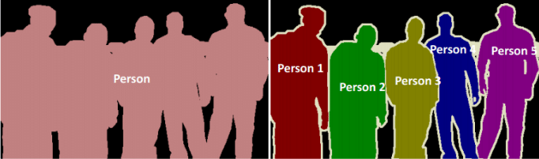

Figure 1: Image segmentation: Difference between semantic and instance [14]

The task PCWN is being used for is semantic segmentation. Semantic segmentation can be used to segment images into any number of classes, but for this use case there will only be 2 classes, this is called binary segmentation.

### PCWN

The PCWN architecture is a hybrid of CNNs and wavelet transforms. The network consists of a contracting path, which decomposes an input, and an expanding path, which reconstructs the input. As previously stated, PCWN is meant for linear inverse tasks, where an image with missing data is reconstructed with the missing data predicted by the model. Segmentation is not a reconstruction, and as such the task requires an adaptation to PCWN that will be discussed in the experiment methods section.

#### Decomposition Step

The first step of decomposition is applying any activation functions. The network can work without them, but activations can be helpful for regularizing activity in the network. One activation function that may be of use is the hyperbolic tangent (tanh) and the inverse hyperbolic arctangent (atanh). This activation “squashes” the input between -1 and 1.

The formula for calculating tanh is:

$$\tanh\left(x\right)= \frac{e^{x}-e^{-x}}{e^{x}+e^{-x}}$$

And the inverse is:

$$\operatorname{atanh}\left(x\right)=\frac{1}{2}\log\left(\frac{1+x}{1-x}\right)=\tan^{-1}{(x)}$$

Figure 2: Illustration of tanh and atanh

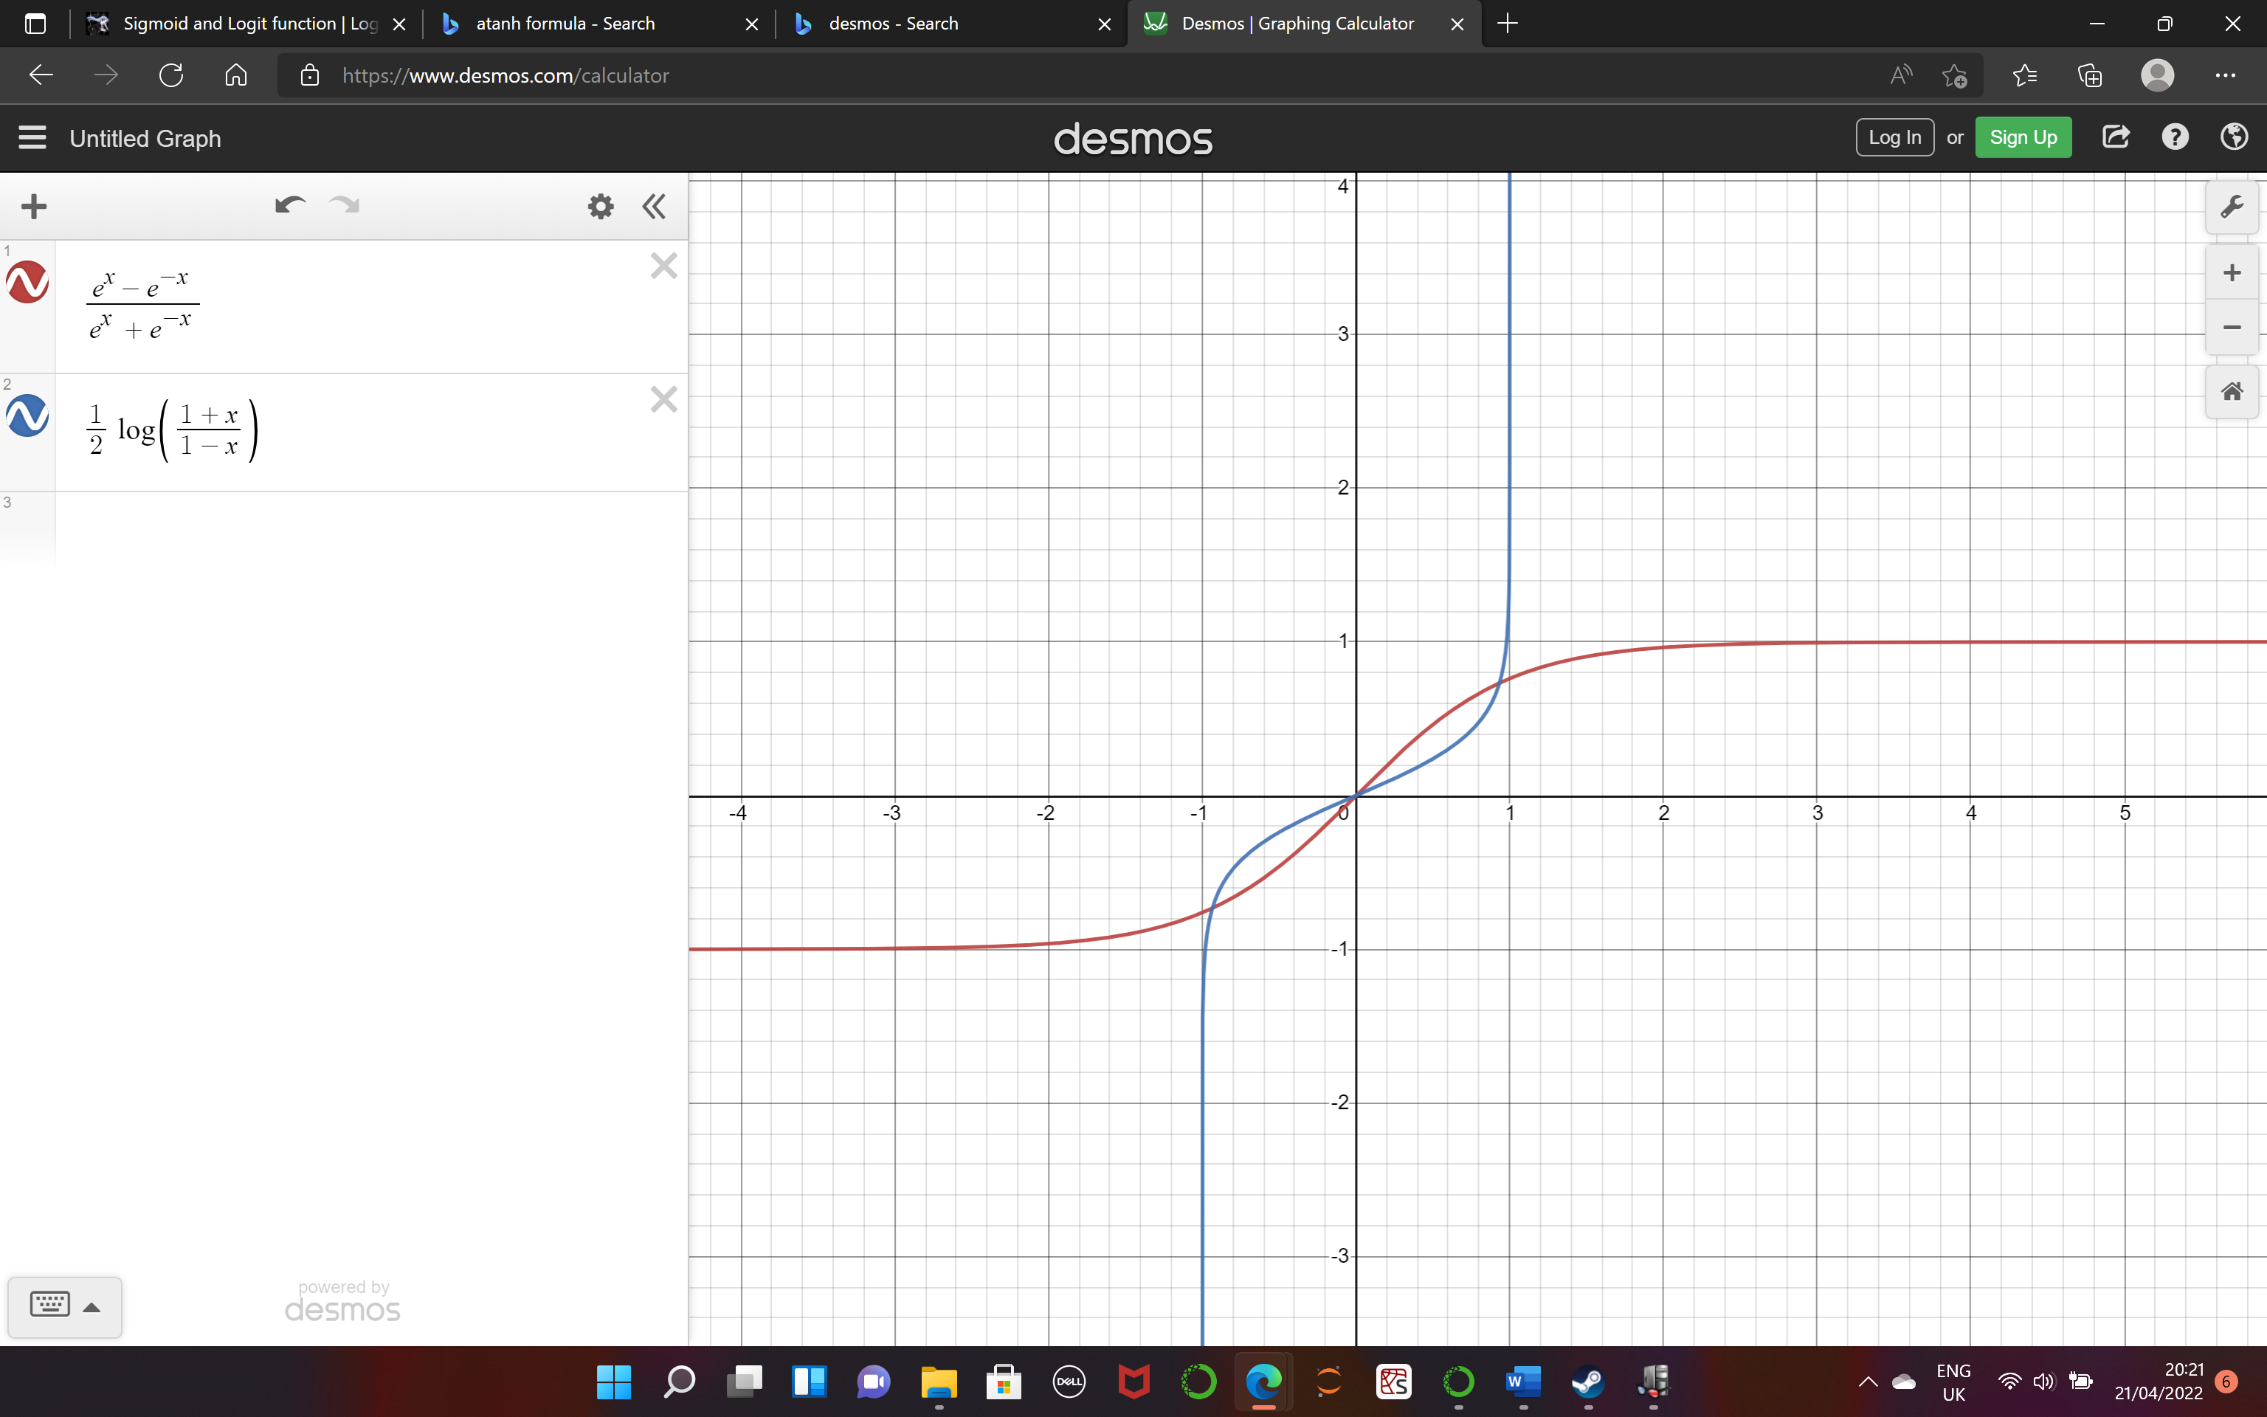

The bank of wavelet filters used in PCWN are discrete and invertible. At every level of decomposition, each filter in the filter bank is applied to each channel in the partial decomposition. The filter bank used is based on approximations of the zeroth, first and second derivatives of the gaussian, applied along the x and y direction. Every input channel outputs 9 more channels in the next decomposition. This process is shown by the following formula:

$$t_{l+1}\left(9z+3j+i\right)= G_{i}^{x}*G_{j}^{y}*s_{l}(z)$$

Where $t_{l+1}\left(9z+3j+i\right)$ is the decomposition at tensor channel $“9z+3j+i”$ at level $“l+1”$ before PCA is applied. $s_{l}\left(z\right)$ is the decomposition tensor channel $z$ at level $l$ of the decomposition, after PCA has been applied, or alternatively it is the input. $G_{i}^{x}$ and $G_{j}^{y}$ are 1D Gaussian derivatives in order $x$ and $y$ of order $i$ and $j$ respectively, where $i∈0,1,2$ and $j∈0,1,2$.

Below is an example of one level of wavelet decomposition. The input is an image, which naturally has 3 channels, red, green, and blue. The number of output channels is 27, however many of these channels are redundant. Therefore, PCA is used, to reduce the number of channels, whilst retaining the variance. The full decomposition step applies the filter bank and then projects the output into the PCA subspace

To project the decompositions into the PCA subspace is simple once the principal components are calculated. The projection is accomplished as a weighted sum of the channels in the decomposition.

Figure 3: Wavelet decomposition of an image of a bird

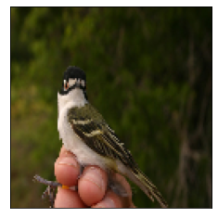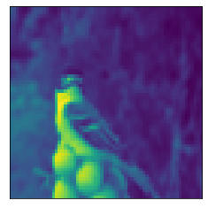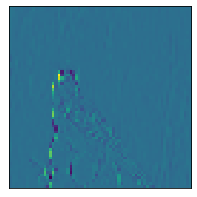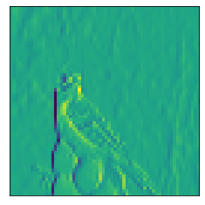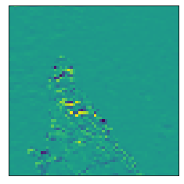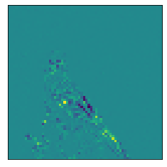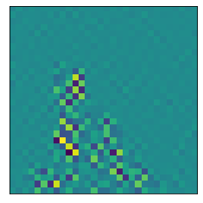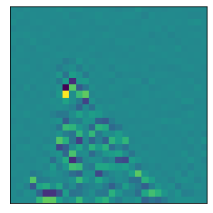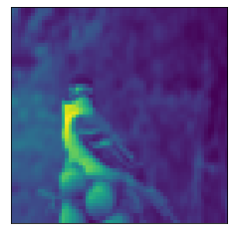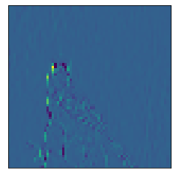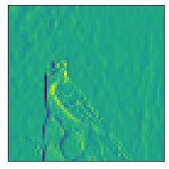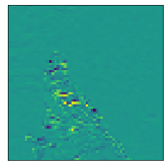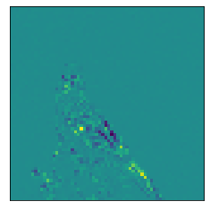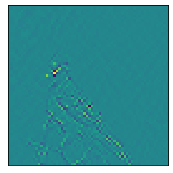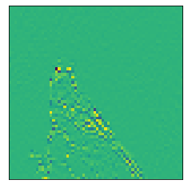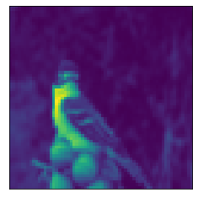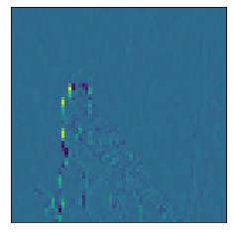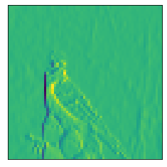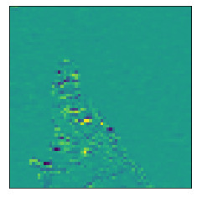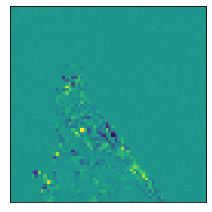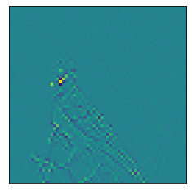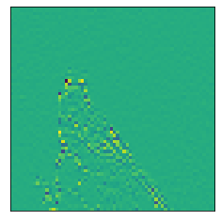

is the PCA decomposition of channel $z$ of the tensor. $Z_{l}$ is the number of channels before projection into PCA subspace. $W_{l}(z,i)$ is the $i^{th}$ component of the $z^{th}$ principal component at level $l$ in the decomposition. $b_{l}\left(z\right)$ is the bias term, which is calculated as the dot product of the negative of the mean and the principal component.

#### Training

A point of note is that PCWN does not use stochastic methods for learning such as backpropagation. This means the outcome of a PCWN is deterministic which has the advantage of repeatable results.

The PCWN trains sequentially, layer by layer. The training process loops over every image and feeds it through the filter bank. This creates a feature map, with many redundant channels. Every 2D position in this feature map is a vector, where the length of the vector is the number of channels in the decomposition. The vectors are used to calculate the covariance matrix and the mean of the data. Using the covariance matrix and mean the principal components are calculated. The number of principal components kept can be a fixed number or the number required for a specific explained variance.

Figure 4: PCA training process [1]

A point to note is that the training process happens in every layer of the decomposition part of the network. This is why the PCA step is so important, as without it the number of channels would rapidly increase.

For every decomposition layer that is calculated, a corresponding reconstruction layer is also created

#### Reconstruction Step

Reconstructing the image is effectively the reverse of the decomposition steps. The first step is to apply the inverse of any activation functions to the decomposition. The result of this is the filtered images expressed in the PCA subspace. Reversing the PCA step is accomplished with the following equation.

$$t_{l}^{'}(z) = m_{l}(z) + \sum_{i=0 }^{T_{l}}{W_{l}\left(i, z\right)s_{l}(i)}$$

Where $m_{l}(z)$ is the mean for channel $z$ or level $l$ of the decomposition, $T_{l}$ is the number of principal components used in level $l$, $W_{l}\left(i, z\right)$ is the $z^{th}$ component of the $i^{th}$ principal component at level $l$ in the decomposition, and $s_{l}\left(i\right)$ is the filtered image in PCA subspace that we are reconstructing.

The next step is to reverse the wavelet filters. This step is accomplished using either the Moore-Penrose pseudo inverse or using reconstruction filters with compact support. Compact support means that the wavelet produces a value of 0 outside of some finite interval. The pseudo inverse method woks b constructing a filter matrix $Φ$ which is the function of the wavelet filtering including the stride and border handling, and calculating the inverse of $Φ$ using the formula:

$$Φ^{'}={\left(Φ^{t}Φ\right)}^{-1}Φ^{t}$$

Where $Φ^{'}$ is the pseudoinverse. The pseudoinverse is then applied to the decomposition, which is now in the filter subspace, after the PCA has been reversed. The result of multiplying $Φ^{'}$ with the decomposition is the previous decomposition. If this is the last layer of the reconstruction, then the result is the reconstructed image.

### Deep Learning Architectures for Segmentation

#### U-Net Architecture

The U-net architecture was conceived in 2015 and is so called because of its U-shaped architecture. The success of U-map comes from the use of skip connections. These are connections in the network that allow layer outputs to bypass layers of the network. The result is then concatenated or reintroduced later in the network. Skip connections, or residual connections, first appeared in highway networks [15]. Highway networks implemented skip connections with gates, like a long-short term memory (LSTM) [16] mechanism. Perhaps the most famous architecture to use skip-connections is ResNet [17], an image recognition network that is still used as a benchmark today.

Modern methods for image segmentation use multi-scale feature maps, which means the feature maps encodes information from small resolution features, such as a paw in an image of a cat, as well as large scale features, such as the background of the image. U-net is not an exception. Skip connections allow U-net to use multi-scale feature maps when calculating the segmentation mask.

In a standard fully convolutional network there is a contracting path, which reduces the resolution of the feature map with every successive convolution and pooling operation. This means that feature information is lost, especially information regarding location of the object being segmented. Skip connections means that the network can retain information that would otherwise be lost. This is illustrated in the network architecture below.

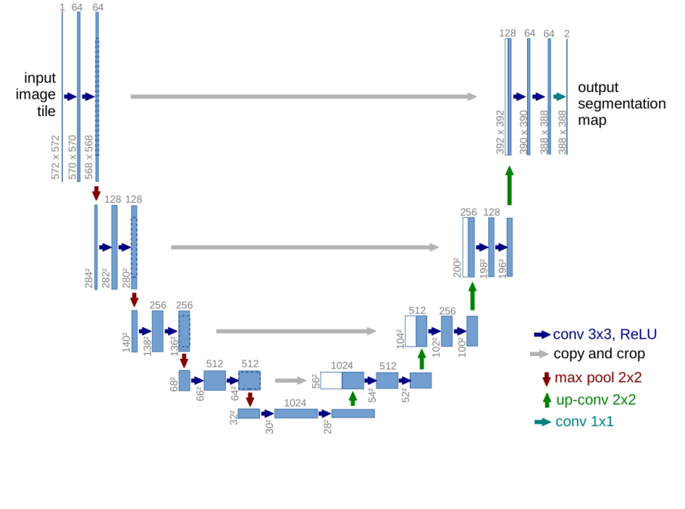For image segmentation, the location of an image is important in constructing the mask. By using skip connections, it is possible to reuse high-resolution features to supplement up-sampled outputs from deeper layers, resulting in a more precise output. In the below example the blue box shows the location information provided by the high resolution feature to the low resolution feature in the yellow box.

Figure 5: U-net architecture [3]

#### Graphical user interface, text, application, Word Description automatically generatedDeeplabV3 Architecture

Figure 6: Example of high-resolution features being used to localize low-resolution features [3]

The DeepLabV3 is state of the art for semantic segmentation. The approach proposes the use of atrous convolutions, used in a method called Atrous Spatial Pyramid Pooling (ASPP) [18]. ASPP resamples a feature map with multiple atrous filters of increasing dilation and combines the resultant map using a pooling operation. Atrous convolutions are convolutional filters with a dilation rate which determines the padding between values in the filter. Atrous convolutions are excellent for multi-scale features, capturing dense features whilst maintaining the resolution of resultant feature maps. As mentioned, when discussing U-net, deep convolutional networks that use pooling and striding do not maintain resolution of feature maps, meaning information is lost.

The formula for calculating a 1-dimensional atrous convolution is:

$$y[i]=\sum_{k}{x[i+r∙k]∙w[k]}$$

Where y is the output feature map, x is the image, i is a location in x and y, r is the atrous rate and w is the kernel. By increasing the atrous rate, we increase the number of zeros between consecutive values in the filter. For example, an atrous value of 1 is a conventional filter. An atrous rate of 2 pads one zero between every value in the filter.





Figure 7: Atrous convolution: Atrous rate = 1

Figure 8: Atrous convolution: Atrous rate = 2

The reason for including details on DeeplabV3 and atrous convolutions is that the ASPP method could be applied to future PCWN work. Atrous convolutions have been used with undecimated wavelet networks before successfully [19] and would be an interesting edit to the PCWN architecture, however ASPP was beyond the scope of this project.

### Research Questions

There were several initial questions posed:

* Can you apply the network to a novel task?
  + Image segmentation
  + Crowd counting
* Can another dimensionality reduction be used instead of PCA?
* What are the effects of changing network parameters?

Of these questions, I have completed 2, and would suggest the remainder for a future project.

#### Can you apply the network to a novel task? (Image Segmentation)

This task was the main focus of the project. There are a number of technical aspects to answering this question which were expected to take a long time, which is why the remaining questions have been delegated to future research.

#### What are the effects of changing network parameters?

This task is a natural extension of the segmentation task. Some experimentation would be required to determine the best parameters for segmentation. There are several parameters to vary through experiments. For the model, the parameters to edit include layer count, percentage of channels kept, different architectures and different activation functions. For the dataset, the editable parameters are image resolution and training data size.

## Process

### Overview

The project was an individual effort which meant an exact agile methodology was not an appropriate choice for the task. Waterfall planning was not appropriate either, as the requirements were not clear at the start of the project. The most sensible approach was to select aspects of agile to apply to account for the unknown requirements of the project and the consequent changes. I used Kanban boards to track my progress in the project.

A using Kanban tools is most effective in a team. As the project was carried out by an individual there required some adaption to the techniques. The changes were mostly simplifications of the method, such as removing work in progress (WIP) limits. Lots of features are only beneficial when working as a team, removing them streamlined development as less time was spent on features intended to improve collaboration.

Figure 9: screenshot of the Kanban board used for tracking tasks, using click-up https://app.clickup.com/

Week-long iterations emerged naturally, as there were weekly meetings with the project supervisor. During these meetings there were discussions about current progress, and the next set of features to implement. This customer orientated, with the project supervisor as the customer, is consistent with feature driven development. The features were not agreed at the beginning of the project, rather they were the product of weekly meetings with the supervisor.

There were 4 iterations of the software, corresponding to roughly 5 weeks of development work. With 3 weeks used for research at the beginning of the project and the remaining time dedicated to writing the report.

Table 1: Table of features

|  |  |  |  |  |  |
| --- | --- | --- | --- | --- | --- |
| Feature No | Feature Name | Complexity (1-10) | Priority | Description | Implemented |
| F1 | Connected PCWN | 7 | High | Set up fully connected PCWN for image segmentation | Yes |
| F2 | Convolutional PCWN | 8 | High | Set up convolutional PCWN for image segmentation | Yes |
| F3 | U-net | 6 | High | Set up a U-net architecture for segmentation | Yes |
| F4 | Deep CNN | 5 | Medium | Set up a deep autoencoding CNN for segmentation | Yes |
| F5 | Loading bird dataset | 2 | High | Develop a method for easily loading the Caltech bird dataset into test-train splits | Yes |
| F6 | Loading pet dataset | 2 | Medium | Develop a method for easily loading the Oxford pet dataset into test-train splits | Yes |
| F7 | Image pre-processing | 3 | High | Processing and standardising the images to make it easier for models to learn | Yes |
| F8 | Segmentation pre-processing | 4 | High | Processing and standardising the segmentation mask to make it easier for the models to learn | Yes |
| F9 | Automated experiments for PCWN | 5 | Low | A notebook for testing numerous settings for PCWN models | Yes |
| F10 | U-net combined with PCWN | 9 | Low | Adding skip-connections to PCWN, resulting in a U-net like architecture | No |
| F11 | Multi-label segmentation | 5 | Low | Extending models to work with multi-label segmentation datasets | No |
| F12 | PCA alternatives | 9 | Low | Replacing PCA in the network with a different dimension reduction technique | No |

### Iteration 0 - Setup

Iteration 0 corresponds to the research and spike work for this project. The first steps were to set up development software such as GitHub [20], Jupyter Notebooks [21], Spyder [22] and Anaconda [23]. This also included setting up the directory structure and cloning the GitHub repository with the original code (<https://github.com/bptiddeman/PCWN.git>), selecting the files that would be useful for the segmentation task.

### Iteration 1

The first features implemented were the dataset loading and preprocessing features [F5,F6,F7&F8]. These were the first features to develop as it would be impossible to train any models without data in a sensible format.

The next feature to develop was the connected PCWN [F1]. This is a simpler architecture than the convolutional approach which is why it is the first to be developed.

### Iteration 2

The next feature developed was the convolutional PCWN [F2]. The convolutional aspect added some difficulty, but overall the method was not vastly different to the connected PCWN. There was more time available in this iteration as lessons were learnt from developing the fully connected approach. This left time to develop the U-net architecture [F3].

### Iteration 3

Iteration 3 was spent perfecting the U-net model and developing the autoencoding CNN model [F4]

There was time dedicated to tweaking the PCWN models’ parameters to see which parameters should be varied in the experiments and what kind of ranges should be used.

### Iteration 4

Using the data collected from the manual experiments previously, an automated notebook [F9] was created to systematically test different model configurations such as keep percent, layers and image resolution. This iteration was dedicated to collecting data for analysis, from the PCWN and deep learning models.

# Experiment Methods

## Hypotheses

* PCWN will have similar results to a deep autoencoding CNN
* PCWN will improve with more layers
* U-net will be the better approach than PCWN

## Hardware

Originally, the experiments were run on a HP laptop with 8GB of RAM, a quad-core intel I7-7500 CPU @ 2.7GHz with no GPU and an windows operating system. However, there were significant issues with memory management which incentivised upgrading the laptop to a newer model. AWS was considered, with an exploration of free tiers of elastic computation instances. Instead of AWS, I upgraded the laptop to a newer model, as it was quite old.

The new model was a Dell laptop with 16GB of RAM, an octo-core intel I7-11800H CPU @2.3GHz and a NVIDIA GeForce RTX 3060 GPU, running windows as an operating system. This upgrade solved the memory issues and sped up the experiments.

## Datasets

There were two datasets used, California Tech Birds Dataset (2010) [24] and the Oxford-IIIT Pet Dataset [25]. These datasets were selected as it would be reasonably easy to turn the segmentation masks used in the datasets into binary segmentation masks using modular division. Both datasets have around 7000 images.

## Metrics and Measurements

### Dice Coefficient and Intersection Over Union (IOU)

Monitoring the training process and comparing the performance of different models relies on the use of metrics for measuring the accuracy of segmentation masks. The simplest way of doing this is pixel error, which is the number of pixel locations where the predicted mask and actual mask disagree. This method would be easy to implement however its too sensitive to small displacements in the location of the boundaries of the masks.

One candidate metric to use is Intersection Over Union (IOU) [26] , or the Jaccard index. The IOU measures the intersection of the predicted and actual masks, divided by the union of both the masks. IOU can be visualized as shown here.

Figure 10: Visualisation of IOU [27]

The formula for calculating IOU is:

$$IOU= \frac{TP}{TP+FP+FN}$$

The second possible metric is the Dice coefficient [28, 29]. The Dice s coefficient core is calculated the same way as the F1 score, or the harmonic mean, the formula is very similar to the Jaccard index, but the Dice coefficient weights true positives higher.

$$DiceScore= \frac{2TP}{2TP+FP+FN}$$

The Dice score and Jaccard index have very similar formulas. Dice score is used instead of the IOU as IOU is a better indicator of the worst-case performance whereas dice score is a better indicator of average performance [30]. Both methods do not cope well with examples where the segmentation mask is very small, however both the oxford pet dataset and the California tech bird dataset use segmentation mask that cover 40% of the image on average, so small masks should not be an issue.

### Other Metrics

There are several other metrics that will be recorded, but that may not be used in the experiments. For example, training time will be recorded. This will be helpful in comparing the efficiency of models. The Dice coefficient will be calculated for both the training data and the test data, which will be an indicator of overfitting or underfitting in the PCWN or the deep learning approaches.

## Measuring Performance

The models take too long to train to repeat multiple times, and for PCWN the result is always the same as there is no stochastic to the learning process, it is completely deterministic. This means that every model is trained once, including the deep CNN and U-net models. Standard deviation and mean dice coefficients are calculated by running the models over the dataset and recording values. The IOU will also be recorded, but it won’t be discussed in experiments. The models will be ran on both the bird and the pet dataset, with an image resolution of 128x128.

# Software Design, Implementation and Testing

## Design

### Overall Architecture

The purpose of the software was to generate benchmark image segmentation models, and objectively compare the benchmark models to PCWN models.

The requirements of the software are as follows:

1. Implementation of PCWN architecture for segmentation
2. Implementation of one or more deep-learning methods for segmentation
3. Experiments to find best parameters for PCWN
4. Experiments to compare deep learning methods and PCWN
5. Dataset loading and pre-processing

### PCWN

##### PCWN and Linear Least Squares

PCWNs have worked excellently for linear inverse tasks in computer vision. For segmentation the PCWN architecture requires some edits. The method used for adapting PCWN segmentation is incredibly versatile and can be adapted to several tasks, such as crowd counting and point detection.

The method involves training 2 separate PCWN networks. One network trains on the input, in this case an image. The other network trains on the images with the segmented masks applied. Both networks are only able to reconstruct the inputs, or corrupted versions of them. To extend PCWN to the task of segmentation, there needs to be a method for mapping the decomposition of the image network to the decomposition of the segmentation network.

The mapping can be thought of as a linear equation, where y is the segmentation decomposition, x is the image decomposition, and matrix A and vector b are variables that once solved will map x to y.

$$y=Ax+b$$

Using linear least squares, it is possible to find a solution to this equation quite efficiently and simply. The aim is minimising the expression below:

$$min(\sum_{i}{||Ax_{i}+b-y_{i}||_{2}^{2}})$$

Where $i$ is the number of elements in the dataset.

To do this requires finding the derivatives of each element with respect to A and b and setting them to zero. The derivation is as follows.

$$\sum_{i}{||Ax_{i}+b-y_{i}||_{2}^{2}}= \sum_{i}{\left({Ax}_{i}+b-y_{i}\right){\left({Ax}_{i}+b-y_{i}\right)}^{t}}$$

$$\frac{d}{dA}=2\sum_{i}{({Ax}_{i}+b-y_{i}})x_{i}^{t}=0$$

$$\frac{d}{db}=2\sum_{i}{({Ax}_{i}+b-y_{i}})=0$$

The derivatives are expanded and rearranged.

$$\sum_{i}{\left(x_{i}^{T}y_{i}\right)}=A\sum_{i}{\left(x_{i}^{T}x_{i}\right)}+b\sum_{i}{\left(x_{i}^{T}\right)}$$

$$\sum_{i}{\left(y_{i}\right)}=A\sum_{i}{\left(x_{i}\right)}+nb$$

The vector b is eliminated through substitution:

$$b=\frac{\sum_{i}{(y_{i})}-A\sum_{i}{(x_{i})}}{n}$$

The substitution results in the following equation:

$$A(\sum_{i}{\left(x_{i}^{T}x_{i}\right)}-\frac{\sum_{i}{\left(x_{i}^{T}x_{i}\right)}}{n}) =\sum_{i}{\left(x_{i}^{T}y_{i}\right)}- \frac{\sum_{i}{\left(x_{i}^{T}y_{i}\right)}}{n}$$

For the readers sake, the equation can be simplified by introducing X and Y as substitutions for $\sum_{i}{\left(x_{i}^{T}x_{i}\right)}-\frac{\sum_{i}{\left(x_{i}^{T}x_{i}\right)}}{n}$ and $\sum_{i}{\left(x_{i}^{T}y_{i}\right)}- \frac{\sum_{i}{\left(x_{i}^{T}y_{i}\right)}}{n}$ respectively, giving the following equation.

$$A∙X = Y$$

To find A, both sides of the equation are multiplied by the inverse of X. In practice, the Moore-Penrose pseudo-inverse [31, 32] is used, as the system of linear equations being solved may not have a unique solution.

$A$ = $X^{-1}Y$

It is then trivial to find vector b by substituting A back into the original equation and rearranging:

$$b = \overline{y} – A\overline{x}$$

$\overline{y}$ is the mean of the segmentations and $\overline{x}$ is the mean of the image decompositions.

The method for calculating A and b can be accomplished in 2 ways, a fully connected method, or a fully convolutional method. The method of using linear least squares is the same, but the shape of the tensors is different.

##### Fully Connected Method

Figure 11: Fully connected PCWN architecture

In the fully connected method, the decompositions are flattened. This approach is location variant, and so is suited to images where the object of interest is in a consistent position, such as the centre of the image. When calculated using the fully connected method, the X and Y matrix can become very large. This can cause memory issues, especially when calculating the Moore-Penrose pseudoinverse. The actual size of A is the product of the product of the dimensions of each decomposition.

The method for solving the linear inverse for the fully connected PCWN is exactly as stated in the previous section. However, when using A and b to transform an image decomposition into a segmentation decomposition, the image decomposition must be flattened, and the output is then reshaped, where the shape is that of a valid segmentation decomposition.

The python code for this operation can be found in the appendix.

##### A screenshot of a computer Description automatically generated with medium confidenceFully convolutional method

Figure 12: Fully convolutional PCWN architecture

The fully convolutional method is slightly more complex. This method is appropriate for images where the object of interest does not have a fixed position. The size of the matrix A is much smaller for a convolutional network approach, reducing computational complexity from calculations such as the pseudo-inverse. This means higher resolution images may be used, and deeper networks.

Solving the linear inverse for fully convolutional PCWN is slightly different to the fully connected method, as the convolutional approach uses matrices rather than vectors.

For the most part, the two approaches are very similar. When calculating the covariance between the decompositions, the matrix multiplication between a transposed decomposition and another decomposition is replaced with an outer product multiplication between decompositions. This is effectively the same operation but for a matrix.

The other difference is how the A matrix and b vector are applied when solving y=Ax+b. This method calculates a 1x1 convolutional filter, so A is reshaped as 1x1 filter and then applied to the image decomposition. The bias is added to the result. Again, this is effectively the same process as before but adapted for a matrix.

The python code for this operation can be found in the appendix.

#### Segmentation

Segmentation uses masks formed of nominal values. In binary segmentation, the mask has values of 0 or 1. The problem with using PCA for nominal data is that PCA makes numeric assumptions on the data, which break down when working with nominal data, causing the PCWN to incorrectly reconstruct the segmentation mask as a blurred point.

The workaround used to deal with this is applying the mask to the image, where the image is clipped to pixel values between 10-255, and the segmentation mask is formed of 0’s across every channel. The reason for clipping the image pixel values is to increase the variance between pixels that are in the image, and pixels that are in the segmentation mask, and reduce the chance of a false positive, where a very dark pixel is thought to be part of the mask when training.

The method for doing this takes the element-wise multiple of the image and the inverted mask. The zeros in the mask will set the object pixels to 0 when multiplied together, and the ones in the mask will retain the background pixels.

Figure 13: Original image of bird

Figure 14: Image of bird with mask applied

Figure 15: Inverted segmentation mask

Figure 16: Original segmentation mask

To obtain the original mask, a simple thresholding is applied. The value used for this is 0.01, so any pixel that has a value below this is classified as a mask. For the deep learning methods the original segmentation mask is used as there are no numeric assumptions like with PCA that will cause issues.

### Deep Learning Methods

Two deep learning methods were implemented. The first was the U-net architecture, the second was a deep autoencoding CNN. The reason for implementing two deep learning architectures was to provide some idea on how the skip connections impact the success of a segmentation model, as future PCWN work would look at using skip connections with PCWN. The deep CNN model was implemented to directly compare how a deep learning method compares to PCWN, as they both use a pyramid style decomposition and reconstruction. The U-net model is implemented as it is a standard algorithm used for segmentation.

The U-net architecture has been discussed previously, but the deep autoencoding CNN has not. An autoencoder is an ANN which compresses and encodes an object into some latent representation and reconstructs the object using the latent representation. The latent representation is often called a feature vector. The feature vector has several applications, from image search to data compression. An autoencoding CNN is simply an autoencoder which uses convolutional layers, making the architecture suited for images. The architecture is identical to PCWN, except that the autoencoding CNN trains the filters and does not use PCA. This is the reason why the architecture will be a good comparison for PCWN, as they’re identical apart from a different learning mechanism.

Both models will be made from scratch. This gives more control over the architectures, plus implementing U-net from scratch provides code and experience that would be helpful when converting PCWN to a U-net-like architecture.

## Implementation

### Language

### Development Software

# Results and Conclusions

## Testing of system

### Overall Approach to Testing

Good testing is required for reliable results. Testing was used to check models were working correctly and producing reasonable results.

Testing took a more manual route due to the interactive nature of Jupyter notebooks. Any time functionality needed testing, it was possible to isolate and test it using the cell like structure of the notebooks. This made development incredibly easy.

The use of testing was very important to make sure results were correct and experiments would not crash half-way through. To test the models, a debug flag was used in the data loader, which if set to true would limit the size of the dataset loaded. This meant most tests could be run quickly.

### Stress Testing

Stress testing

## Issues with Experiments

### Memory Errors

By far the most prevalent error was out of memory errors. The cause of this ranged from inefficient programming, insufficient RAM, and poor memory management. To solve the inefficient programming and memory management issues we removed unnecessary objects. The insufficient RAM issue was solved initially by using cloud-based platforms, and then by purchasing a new laptop, upgrading the RAM from 8GB to 16GB.

Memory errors meant initial experiments for the fully connected network were throttled at a 128x128 image resolution. This in turn limited the “count” parameter of the PCWN. This parameter controlled the number of layers in the head, and the inverse head. Every layer reduced the resolution of the composition by half. A 128x128 image would have a feature map with a 4x4 resolution after passing through the head component of a network with 5 layers. This caused an error with the convolutional filters used in reconstruction, as the resolution is too small.

The fully convolutional network had notably fewer memory problems compared to the fully connected version. The reason for this was the calculation of the A matrix, which uses computationally intense methods, such as calculating the pseudo-inverse. The A matrix for the fully connected method was larger than the fully convolutional matrix, meaning the memory usage was much higher for the fully connected variant.

## Experimental Results

## Determining best parameters for PCWN segmentation method

### Convolutional Network Approach

This experiment tests the strength of the convolutional network approach to PCWN. The results are sorted by the mean dice score. We can make several deductions from the results about what factors improve the performance of the model.

Table 2: An experiment on the effect of training size on convolutional PCWN

|  |  |  |  |  |  |  |  |  |
| --- | --- | --- | --- | --- | --- | --- | --- | --- |
|  | **Training data size** | **count** | **Keep percent** | **resolution** | **Dice mean test** | **Dice mean train** | **Linear inverse train time** | **Image train time** |
| **1** | 2000 | 3 | 0.1 | 128 | 0.433 ± 0.227 | 0.419 ± 0.234 | 11.633 | 19.644 |
| **2** | 4000 | 3 | 0.1 | 128 | 0.519 ± 0.212 | 0.506 ± 0.221 | 24.266 | 37.753 |
| **3** | 7049 | 3 | 0.1 | 128 | 0.592 ± 0.196 | 0.585 ± 0.194 | 46.681 | 69.625 |

Figure 17: A graph of training data vs mean dice score

Training data size gives a significant improvement in the score. In the 2 lowest scoring experiments the reduced dataset is being used. Clearly adding more training data has a positive influence on the dice score.

Table 3: An experiment on the effect of keep percent on convolutional PCWN

|  |  |  |  |  |  |  |  |  |
| --- | --- | --- | --- | --- | --- | --- | --- | --- |
|  | **Training data size** | **count** | **Keep percent** | **resolution** | **Dice mean test** | **Dice mean train** | **Linear inverse train time** | **Image train time** |
| **1** | 7049 | 3 | 0.8 | 128 | 0.356 ± 0.236 | 0.390 ± 0.242 | 88.184 | 115.369 |
| **2** | 7049 | 3 | 0.6 | 128 | 0.590 ± 0.196 | 0.583 ± 0.194 | 76.867 | 109.361 |
| **3** | 7049 | 3 | 0.4 | 128 | 0.591 ± 0.196 | 0.584 ± 0.194 | 69.401 | 92.353 |
| **4** | 7049 | 3 | 0.3 | 128 | 0.591 ± 0.196 | 0.584 ± 0.194 | 57.961 | 81.733 |
| **5** | 7049 | 3 | 0.2 | 128 | 0.592 ± 0.196 | 0.585 ± 0.194 | 56.610 | 80.350 |
| **6** | 7049 | 3 | 0.1 | 128 | 0.592 ± 0.196 | 0.585 ± 0.194 | 48.890 | 73.204 |

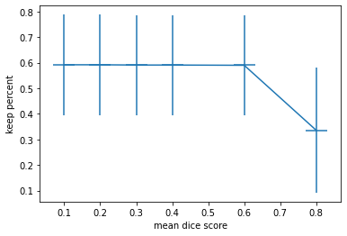

Figure 18: A graph of keep percent vs mean dice score

Keep percent has a negligible effect on the dice score until higher values are reached. The training time is significantly improved by reducing the keep percent. When the keep percent is above 0.6 the dice score dramatically decreases, for both the test and train datasets. However, to increase the layer count there needs to be an increase in keep percent, otherwise the network can collapse as the decompositions become too small.

Table 4: An experiment on the effect of layer count on convolutional PCWN

|  |  |  |  |  |  |  |  |  |
| --- | --- | --- | --- | --- | --- | --- | --- | --- |
|  | **Training data size** | **count** | **Keep percent** | **resolution** | **Dice mean test** | **Dice mean train** | **Linear inverse train time** | **Image train time** |
| **1** | 7049 | 3 | 0.1 | 128 | 0.592 ± 0.196 | 0.585 ± 0.194 | 48.890 | 73.204 |
| **2** | 7049 | 4 | 0.1 | 128 | 0.602 ± 0.182 | 0.595 ± 0.183 | 65.922 | 112.661 |
| **3** | 7049 | 5 | 0.1 | 128 | 0.607 ± 0.178 | 0.597 ± 0.177 | 86.203 | 202.736 |

Figure 19: A graph of layer count vs mean dice score

There is a strong relation between layer count and mean dice score. The more layers the better the performance. Adding more than 5 layers requires increasing the image resolution and keep percent to keep the decomposition size large enough that the model doesn’t collapse.

Table 5: An experiment on the effect of image resolution on convolutional PCWN

|  |  |  |  |  |  |  |  |  |
| --- | --- | --- | --- | --- | --- | --- | --- | --- |
|  | **Training data size** | **count** | **Keep percent** | **resolution** | **Dice mean test** | **Dice mean train** | **Linear inverse train time** | **Image train time** |
| **1** | 7049 | 3 | 0.1 | 256 | 0.585 ± 0.200 | 0.577 ± 0.198 | 109.921 | 160.456 |
| **2** | 7049 | 3 | 0.1 | 128 | 0.592 ± 0.196 | 0.585 ± 0.194 | 46.681 | 69.625 |
| **3** | 7049 | 3 | 0.1 | 64 | 0.600 ± 0.189 | 0.592 ± 0.188 | 32.274 | 46.893 |

Figure 20: A graph of image resolution vs mean dice score

Figure 21: Example segmentation from the convolutional PCWN, dice score = 0.820 ± 0.160

### Connected Network Approach

Table 6: An experiment to show the effect of training data size on connected PCWN

|  |  |  |  |  |  |  |  |  |
| --- | --- | --- | --- | --- | --- | --- | --- | --- |
|  | **Training data size** | **count** | **Keep percent** | **resolution** | **Dice mean test** | **Dice mean train** | **Linear inverse train time** | **Image train time** |
| **1** | 2000 | 3 | 0.1 | 128 | 0.437 ± 0.162 | 0.924 ± 0.103 | 323.406 | 21.657 |
| **2** | 4000 | 3 | 0.1 | 128 | 0.455 ± 0.164 | 0.870 ± 0.147 | 624.663 | 42.169 |
| **3** | 7049 | 3 | 0.1 | 128 | 0.550 ± 0.161 | 0.681 ± 0.181 | 1128.817 | 75.411 |

Figure 22: A graph of training data vs mean dice score

Table 7: An experiment to show the effect of keep percent on connected PCWN

|  |  |  |  |  |  |  |  |  |
| --- | --- | --- | --- | --- | --- | --- | --- | --- |
|  | **Training data size** | **count** | **Keep percent** | **resolution** | **Dice mean test** | **Dice mean train** | **Linear inverse train time** | **Image train time** |
| **1** | 7049 | 3 | 0.1 | 128 | 0.550 ± 0.161 | 0.681 ± 0.181 | 1132.446 | 73.672 |
| **2** | 7049 | 3 | 0.2 | 128 | 0.516 ± 0.163 | 0.744 ± 0.192 | 5797.012 | 80.931 |
| **3** | 7049 | 3 | 0.3 | 128 | 0.526 ± 0.150 | 0.744 ± 0.192 | 15121.520 | 86.131 |
|  | 7049 | 3 | 0.4 | 128 | 0.508 ± 0.150 | 0.744 ± 0.192 | 23655.138 | 94.741 |

Figure 23: A graph of keep percent size vs mean dice score

Table 8: An experiment to show the effect of layer count on connected PCWN

|  |  |  |  |  |  |  |  |  |
| --- | --- | --- | --- | --- | --- | --- | --- | --- |
|  | **Training data size** | **count** | **Keep percent** | **resolution** | **Dice mean test** | **Dice mean train** | **Linear inverse train time** | **Image train time** |
| **1** | 7049 | 3 | 0.1 | 128 | 0.550 ± 0.161 | 0.681 ± 0.181 | 1128.817 | 75.411 |
| **2** | 7049 | 4 | 0.1 | 128 | 0.580 ± 0.171 | 0.707 ± 0.191 | 1173.656 | 123.507 |
| **3** | 7049 | 5 | 0.1 | 128 | 0.569 ± 0.184 | 0.644 ± 0.176 | 1288.608 | 227.213 |

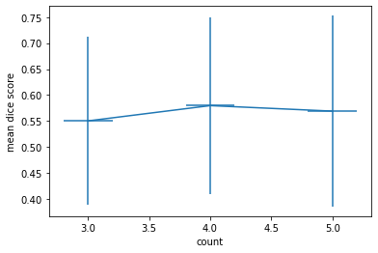

Figure 24: A graph of layer count vs mean dice score

There is no clear benefit gained from increasing layer count with the fully connected approach. Furthermore the

Table 9: An experiment to show the effect of image resolution on connected PCWN

|  |  |  |  |  |  |  |  |  |
| --- | --- | --- | --- | --- | --- | --- | --- | --- |
|  | **Training data size** | **count** | **Keep percent** | **resolution** | **Dice mean test** | **Dice mean train** | **Linear inverse train time** | **Image train time** |
| **1** | 7049 | 3 | 0.1 | 64 | 0.592 ± 0.172 | 0.617 ± 0.177 | 110.172 | 57.156 |
| **2** | 7049 | 3 | 0.1 | 128 | 0.550 ± 0.161 | 0.681 ± 0.181 | 1128.817 | 75.411 |
| **3** | 7049 | 3 | 0.1 | 256 | 0.500 ± 0.164 | 0.745 ± 0.193 | 21648.167 | 166.170 |

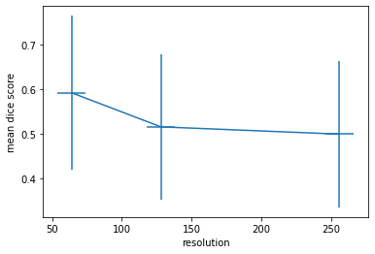

Figure 25: A graph of resolution vs mean dice score

## Experimental Results: PCWN vs Deep Learning

All the models were trained using the full dataset from the Oxford Pets dataset and the California bird’s dataset. The images with 128x128 resolution.

The settings used for the fully connected PCWN were 5 layers, 0.3 keep percent

The settings used for the fully connected PCWN were 5 layers, 0.3 keep percent

|  |  |  |
| --- | --- | --- |
|  | **Oxford Pets** | **Caltech Birds** |
| **U-net** | 0.850 ± 0.123 | 0.745 ± 0.194 |
| **Deep CNN** | 0.813 ± 0.120 | 0.718 ± 0.219 |
| **Convolutional PCWN** |  |  |
| **Connected**  **PCWN** |  |  |

# Critical Evaluation

Overall, the project was a success. The core goal of getting PCWN to work for segmentation was achieved despite technical difficulties. There was considerable research undertaken for this task, especially into wavelets, invertible networks and deep learning techniques for segmentation. The project was more complex than anticipated and required specific design choices to make PCA based methods work for segmentation.

## Background and Research

The project was incredibly exploratory, taking 3 weeks for any concrete objectives for features to emerge. During this time there was a lot of work done in understanding PCWN architecture and segmentation networks. There was some pre-existing familiarity with PCA and deep learning techniques for computer vision, however there is a large difference between a basic understanding of the principles, to implementing them. Lots of spike work was done in this stage, taking the code from the paper and debugging it was a relatively easy task, taking no more than a week. The background research was possibly the favourite part of the project, it was incredibly invigorating to discover new developments in computer vision and the broader field of artificial intelligence. In hindsight too much time was spent on research, due to being overwhelmed with the possibilities and directions the project could take.

## Design

* Were the design decisions correct?

## Implementation

The implementation also proved challenging. Once the code and paper were understood, getting the PCWN architecture to work was relatively easy. The main difficulty was writing the linear least squares method to map the image decomposition to the segmentation decomposition. This process was massively hampered by the hardware being used. Calculating the inverse was causing out of memory errors or crashing python. There were also some issues around some of the linear algebra used. Matrix multiplication is non-commutative $(X^{T}X ≠XX^{T})$, and in the code there was confusion between which way round the matrices should have been. If the project was to be repeated, there would be more research into how linear least squares is derived before writing the code, to prevent confusion.

The method for adapting segmentation masks to be amenable for PCA could probably be improved, or the PCA method could be changed to non—linear PCA. The approach taken to getting PCA to work for segmentation seemed non-optimal and unorthodox. With more research and better planning a better solution would have emerged, such as using non-linear PCA.

Overall, the implementation is the part of the project was the weakest part of the project. I feel too much time was spent dealing with hardware issues and solving compatibility issues between the novel implementation and the code from the PCWN paper. However, this is the reality of working with software, so it came as no great surprise. If the project was to be done project, more concrete objectives early on would be very useful. A lot of time was spent deciding between directions to take the project, doing spike work and research for each option. If more concrete objectives had been set then there would be less time undertaking needless work, and more time focusing on the actual objectives.

## Testing

With testing it was actually very difficult to write a useful test. Agile approaches break down when it comes to notebooks as we can easily test any functionality through “execute and check”. In a way, there were many tests, I used the execute and check method countless times, mostly as sanity checks. The python files required some testing, but all the functionality of the files was used by the notebooks, where the tests could be run using execute and check again.

## Methodology

The methodology of feature driven development was the correct approach to aspire to. This does not mean the approach was followed rigorously. I found the Kanban board incredibly helpful towards the beginning of the project, as I was able to lay out the objectives ahead and plan my time accordingly. This worked very well for a majority of the project. I felt confident going into most meetings that time had been managed well and I was on track with my project. Retrospectively, it would have been helpful to have more 1-on-1’s with the project supervisor, as many of the problems I had were quickly resolved during these sessions. However, at the time I did not want to bother the supervisor too much.

## Reflection

# Bibliography

|  |  |
| --- | --- |
| [1] | B. Tiddeman and M. Ghahremani, "Principal Component Wavelet Networks for Solving Linear Inverse Problems," *Symmetry,* vol. 13, no. 6, p. 1083, 2021. |
| [2] | J. Bruna and S. Mallat, "Invariant Scattering Convolution Networks," *IEEE transactions on pattern analysis and machine intelligence,* vol. 35, no. 8, pp. 1872-1886, 2013. |
| [3] | R. Olaf, P. Fischer and T. Brox, "U-net: Convolutional networks for biomedical image segmentation," in *International Conference on Medical image computing and computer-assisted intervention*, Cham, 2015. |
| [4] | S. C. Yurtkulu, Y. H. Şahin and G. Unal, "Semantic Segmentation with Extended DeepLabv3 Architecture," in *2019 27th Signal Processing and Communications Applications Conference (SIU)*, 2019. |
| [5] | S. Ghosh, et al, ""Understanding deep learning techniques for image segmentation."," *ACM Computing Surveys (CSUR),* vol. 52, no. 4, pp. 1-35, 2019. |
| [6] | R. E. Bellman, Dynamic Programming, Princeton University Press, 1957. |
| [7] | D. Rumelhart, G. Hinton and R. Williams, "Learning represntations by back-propagating errors," *Nature,* vol. 323, no. 9, pp. 523-536, 1986. |
| [8] | K. Fukushima, "Neocognitron: A Self-organizing Neural Network Model," *Biological ,* vol. 36, pp. 193-202, 1980. |
| [9] | Y. LeCun, B. Boser, J. S. Denker, D. Henderson, R. E. Howard, W. Hubbard and L. D. Jackel, "Backpropagation Applied to Handwritten Zip Code Recognition," AT&T Bell Laboratories, Holmdel, 1989. |
| [10] | A. Haar, "Zur Theorie der orthogonalen Funktionensysteme," *Mathematische Annalen,* vol. 69, no. 3, pp. 331-371, 1910. |
| [11] | P. Viola and M. Jones, "Rapid Object Detection using a Boosted Cascade of Simple," in *Computer Vision and Pattern Recognition*, 2001. |
| [12] | E. Oyallon, S. Zagoruyko, G. Huang, N. Komodakis, S. Lacoste-Julien, M. Blaschko and E. Belilovsky, "Scattering networks for hybrid representation learning," *IEEE Trans. Pattern Anal. Mach. Intell.,* vol. 41, pp. 2208-2221, 2018. |
| [13] | T. Angles and S. Mallat, "Generative networks as inverse problems with scattering transforms," in *ICLR*, 2018. |
| [14] | V. Varatharasan, H.-S. Shin, A. Tsourdos and N. Colosimo, "Improving Learning Effectiveness For Object Detection and Classification in Cluttered Backgrounds," 2020. |
| [15] | R. K. Srivastava, K. Greff and J. Schmidhuber, "Highway Networks," 2015. |
| [16] | S. Hochreiter and S. Jurgen, "Long short-term memory," *Neural computation,* vol. 9, no. 8, pp. 1735-1780, 1997. |
| [17] | K. He, X. Zhang, S. Ren and J. Sun, "Deep Residual Learning for Image Recognition," 2015. |
| [18] | L.-C. Chen, G. Papandreou, I. Kokkinos, K. Murphy and A. L., "Deeplab: Semantic image segmentation with deep convolutional nets, atrous convolution, and fully connected crfs," 2016. |
| [19] | M. Holschneider, R. Kronland-Martinet, J. Morlet and P. Tchamitchian, "A real-time algorithm for signal analysis with the help of the wavelet transform," *Wavelets: Time-Frequency Methods and Phase Space,* pp. 289-297, 1989. |
| [20] | "Github Homepage," GitHub, Inc, [Online]. Available: http://github.com/. [Accessed 29 04 2022]. |
| [21] | "Jupyter Notebook Homepage," Jupyter, [Online]. Available: https://jupyter.org/. [Accessed 29 04 2022]. |
| [22] | Spyder, [Online]. Available: https://www.spyder-ide.org/. [Accessed 29 04 2022]. |
| [23] | "Anaconda Homepage," Anaconda, [Online]. Available: https://www.anaconda.com/. [Accessed 29 04 2022]. |
| [24] | P. Welinder, S. Branson, T. Mita, C. Wah, F. Schroff, S. Belongie and P. Perona, "Caltech-UCSD Birds 200," California Institute of Technology, 2010. |
| [25] | O. M. Parkhi, A. Vedaldi, A. Zisserman and C. V. Jawahar, "Cats and Dogs," in *IEEE Conference on Computer Vision and Pattern Recognition*, 2012. |
| [26] | P. Jaccard, "THE DISTRIBUTION OF THE FLORA IN THE ALPINE ZONE," *New Phytologist,* vol. 11, no. 2, pp. 37-50, 1912. |
| [27] | A. Rosebrock, "Intersection over Union (IoU) for object detection," pyimagesearch, 7 11 2016. [Online]. Available: https://pyimagesearch.com/2016/11/07/intersection-over-union-iou-for-object-detection/. [Accessed 28 04 2022]. |
| [28] | L. R. Dice, "Measures of the Amount of Ecologic Association Between Species," *Ecology,* vol. 26, no. 3, pp. 297-302, 1945. |
| [29] | T. Sørensen, "A method of establishing groups of equal amplitude in plant sociology based on similarity of species and its application to analyses of the vegetation on Danish commons," *The Royal Danish Academy of Science and Letters,* vol. 5, no. 4, pp. 1-34, 1948. |
| [30] | "F1/Dice-Score vs IOU," stackexchange, 12 1 2017. [Online]. Available: https://stats.stackexchange.com/questions/273537/f1-dice-score-vs-iou/276144#276144. [Accessed 25 4 2022]. |
| [31] | R. Penrose, "A generalized inverse for matrices," *Mathematical Proceedings of the Cambridge Philosophical Society,* vol. 51, pp. 406-413, 1955. |
| [32] | E. Moore, "On the reciprocal of the general algebraic matrix," *Bulletin of the American Mathematical Society,* vol. 26, pp. 394-395, 1920. |

# Appendices

The appendices are for additional content that is useful to support the discussion in the report. It is material that is not necessarily needed in the body of the report, but its inclusion in the appendices makes it easy to access.

If you have used any 3rd party code, i.e. code that you have not written yourself such as libraries, then you must include Appendix A. In that appendix, you will provide details of the 3rd party code that you have used.

For most other items, it would be better to include them in your technical submission instead of including them as an appendix. For example:

* If you have developed a Design Specification document as part of a plan-driven approach for the project, then it would be appropriate to include that document in the technical work. In this report, you would highlight the most interesting aspects of the design, referring your reader to the full specification for further detail.
* If you have taken an agile approach to developing the project, then you may be less likely to have developed a full requirements specification at the start of the project. Perhaps you used stories to keep track of the functionality and the ‘future conversations.’ If it isn’t relevant to include all those stories in the body of your report, you could detail those stores in a document in the technical work.
* If you have used manual testing, then include a document in the technical work that records the tests that have been done. In this report, you would talk about the use of those tests.

Documents included in the technical work or in the appendices are supporting evidence of the work done. Where you include documents, this report should refer to the documents. You should not be relying on detailed study of those documents in order to understand what is written in this report.

Speak to your supervisor or the module coordinator if you have questions about this.

* 1. Third-Party Code and Libraries

keras

tensorflow

tensorflow_dataset

numpy

pandas

matplotlib

os

sys

tqdm

seaborn

MajorProject/Code/BaseCode directory

pca_wavelet_utils

* 1. Code Samples

Least Squares: Fully Connected

Calculating matrix A and vector b for least squares. This method is used for the fully connected version, where the decompositions are flattened.

Least Squares: Fully Convolutional

Calculating matrix A and vector b for least squares. This method is used for the convolutional variant of PCWN, and reshapes the decompositions into 2D matrices.

